INTRODUCTION TO CYBERSECURITY

THEORY DAY1
TASK1: Create a table listing 5 key cybersecurity terms (such as threat, vulnerability, risk, asset, attack vector) and write a one-line definition for each in your own words.
Term | Definition
Threat | Anything that can cause harm to a computer system or data.
Vulnerability | A weakness in a system that an attacker can use.
Risk | The possibility of loss or damage because of a threat using a vulnerability.
Asset | Something valuable that needs protection, such as data, computers, or accounts.
Attack Vector | The method or path an attacker uses to enter or attack a system.

TASK2: Research and find a real-world news article from the last 2 years about a major cyberattack on an Indian company or app (for example, a breach involving Zomato, Paytm, or IRCTC). Summarize what happened and identify one threat, one vulnerability, and one risk mentioned in the incident.
Incident: Tata Electronics Cyberattack – 2026
A recent example is the cyberattack on Tata Electronics, an Indian electronics and semiconductor manufacturer. In June 2026, Tata Electronics confirmed that it had identified a cybersecurity incident affecting some of its systems. A ransomware group claimed that it had stolen more than 200,000 files, reportedly totaling more than 630 GB, including documents related to customers such as Apple and Tesla. Tata Electronics said that its business operations remained unaffected while it responded to the incident.
Threat
The main threat was a ransomware/extortion attack, where attackers attempted to steal and expose company information.
Vulnerability
A possible vulnerability was the security weakness in some of the company's IT systems that allowed unauthorized access. The exact technical vulnerability has not been publicly disclosed, so it should not be assumed that a particular software flaw caused the incident.
Risk
The major risk was the exposure of confidential business and customer information, which could cause financial loss, reputation damage, and privacy problems.
Result: This incident shows why companies need strong security controls, monitoring, backups, and protection for sensitive data.
TASK3: Sign up for a free account on any online cybersecurity dashboard or threat intelligence tool (such as https://www.cybermap.kaspersky.com/ or https://threatmap.checkpoint.com/). Take a screenshot of the dashboard and list 3 types of information or metrics you see displayed.
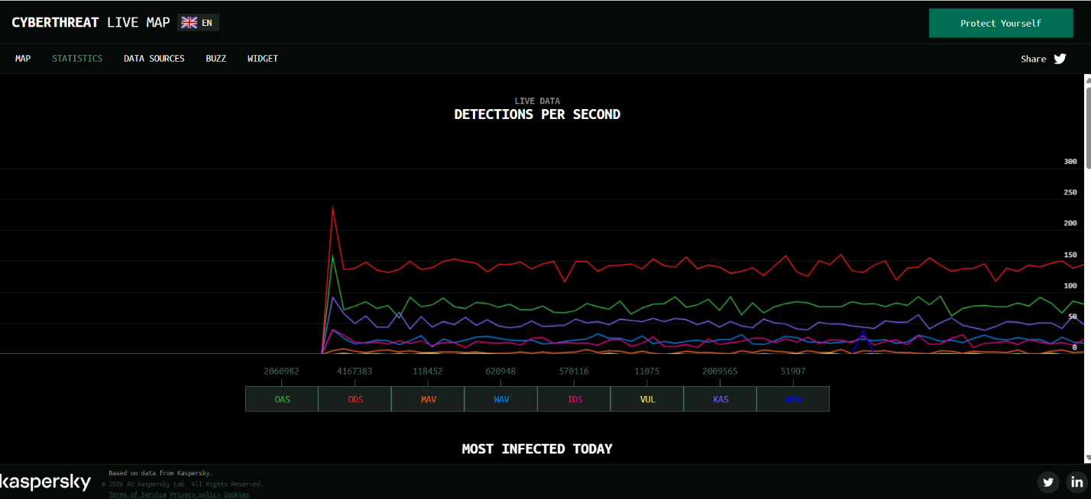
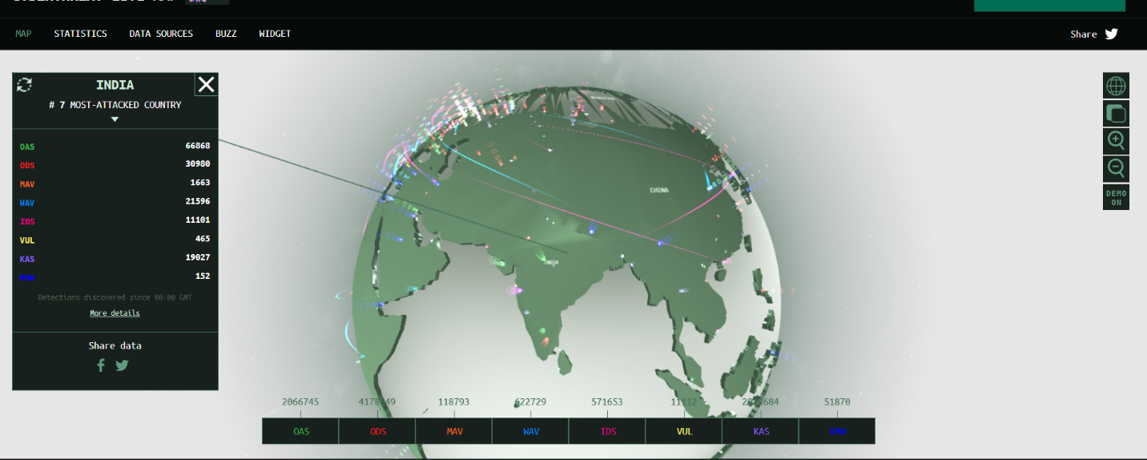
TASK4: Write a simple phishing email template targeting users of a popular app (for example, 'Your Paytm account is suspended, click here to verify'). Highlight the suspicious elements that make it a phishing attempt.<br><br><em><strong>Hint:</strong> Think about fake links, urgent language, or requests for sensitive info.</em>
EXAMPLE:
Subject: Your Paytm Account Has Been Suspended
Dear Customer,
Your Paytm account has been temporarily suspended because we detected unusual activity.
Click here immediately to verify your account: http://paytm-security-verification.example
If you do not verify your account within 24 hours, your account may be permanently blocked.
Thank you,
Paytm Security Team

SUSPICIOUS ELEMENTS:
- Urgent language: "within 24 hours" tries to make the user panic.
- Suspicious link: The link is not an official Paytm website.
- Threat of account blocking: This is used to pressure the user.
- Request for verification: The user may be taken to a fake login page.

TASK5: Use ChatGPT or another AI tool to generate a simulated phishing email for a fictional food delivery app (like 'FoodiePal'). Copy the AI-generated email and explain which parts are likely to trick users and why.
Simulated Email
Subject: Urgent – Your FoodiePal Account Needs Verification
Dear FoodiePal User,
We noticed unusual activity on your account. To keep your account active, please verify your account immediately by clicking the link below:
Verify Your Account: https://foodiepal-security.example/verify
If you do not complete the verification within 24 hours, your account may be temporarily suspended.
Thank you,
FoodiePal Security Team

Suspicious Part | Why It May Trick Users
"Urgent" | Makes the user feel they need to act quickly.
"Unusual activity" | Creates fear that their account may be in danger.
Fake verification link | May lead the user to a fake login page.
24-hour deadline | Pressures the user into clicking without checking.
Security Team name | Makes the email look official and trustworthy.

